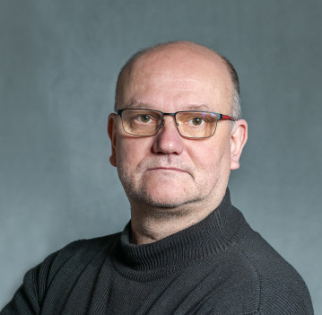
CURRICULUM VITAE

PERSONAL DETAILS

Name: Zsolt Borhegyi
e-mail: Borhegyi.Zsolt@koki.hun-ren.hu

EDUCATION AND QUALIFICATIONS
1995-1998 PhD, Semmelweis University
1990-1995 B.Sc./M.Sc,.Eötvös Lóránd University (ELTE), Neuro-Biologist

PROFESSIONAL EXPERIENCE
2020-present Institute of Experimental Medicine, Budapest, Hungary
2017-2019 ELTE, Budapest, Hungary
2015-2017 MTA-ELTE-NAP B, Budapest, Hungary
2009-2014 Center for Brain Research, Vienna, Austria
1991-2009 Institute of Experimental Medicine, Budapest, Hungary
1998-1999 Rutgers University, Newark, NJ, US
1995-1996 Yale School of Medicine: CT, US
1991-1995 Student research assistant, Inst. of Exp. Medicine, Budapest, Hungary

ACHIEVEMENTS

Prizes:
1993 Bolyai award for excellent work as Student Research Assistant at Eötvös Loránd University
2005 The Young Investigator Award of the Hungarian Academy of Sciences

Fellowships and grants:
1994 Travel Grant from European Neuroscience Association, Wien
1998 Richter Gedeon Research Award
1998-1999 Eötvös fellowship (8 months)
2001-2004 Bolyai scolarship
2002 Travel Grant from IBRO to the FENS meeting in Paris

SELECTED PUBLICATIONS

