CURRICULUM VITAE

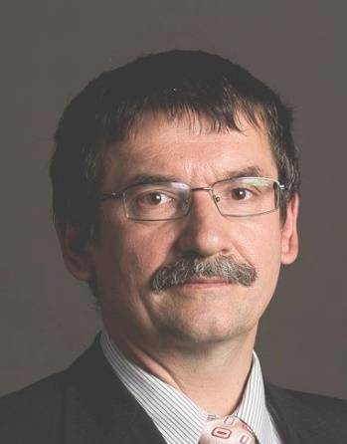

PERSONAL DETAILS

Name: Ákos Zarándy
e-mail: zarandy.akos@hun-ren.sztaki.hu
workplace: HUN-REN SZTAKI

EDUCATION AND QUALIFICATIONS

- 2010 DSC of the Hungarian Academy of Sciencies
- 1997 Ph.D. in Computer science, Hungarian Academy of Sciences:
"CNN Universal Machines: spatial logic, colors, and illusions"
- 1992 MsC, Electrical Engineering, Technical University of Budapest, Hungary

PROFESSIONAL EXPERIENCE

- 2015- Board of Roska Tamas Doctoral School (Pazmany Peter Catholic University)
- 2012- professor at Pazmany Peter Catholic University
main courses: Neural Networks, Embedded systems
- 2011-present head of the Computational Optical Sensing and Processing Laboratory
- 2007-Senior Research Fellow (SZTAKI, Hungary)
- 2005-2006 CTO (Eutecus Inc. Berkeley, California, USA)
- 2000-2005 CEO (AnaLogic Computers Ltd, Budapest, Hungary, Spin-off company of SZTAKI)
- 1997-2005 Research Fellow (MTA-SZTAKI, Hungary)
- 1992-1997 PhD student (MTA-SZTAKI, Hungary)
- 1993, 95, 96, 98 Visiting scholar or post doc at University of California at Berkeley

ACHIEVEMENTS

- 2021- Digital Holographic microscope
- 2019- Infant monitoring
- 2010-2012: Visual remote airplane detector device for UAVs for collision avoidance
- 2008-2009: Theoretical studies of many-core cellular processor arrays
- 2006-2007: 8x8 nanoantenna sensor interface including per pixel analogue amplifiers and programmable digital filters (100dB signal to noise ratio total) (Project Leader)
- 2005-2006: Focal-plane sensor-processor array with 64 fully programmable on-chip processors: XENON (Project Leader)
- 2004-2005: Locally adaptive image sensor development
- 2002-2005: Biologically motivated collision warning focal-plane sensor-processor array: LOCUST (Group Leader)
- 2002-2003 Bi-i: Industrial grade camera capable over 25,000 FPS visual decision making (capturing and real-time evaluation) Product of the year, Vision 2003, Stuttgart (Project Leader)
- 1996-2000: CNN Chip Prototyping System (chief developer)

Prizes:

- 2022 Kalman Rudolf Award
- 2007 Charles Simonyi Award
- 2007 Microprocessor Report Innovation Award, San Jose, California: Superfast Sensor-Processors Break New Ground in Digital Imaging
- 2005 Best paper award, “Per-pixel integration time controlled image sensor” ECCTD Ireland
- 2003 Product of the year at Stuttgart Vision fair: Bi-i camera
- 2002 John von Kemeny Award
- 2000 Denes Gabor Patent Award
- 1999 General Electrics Scholarship

Fellowships and grants:

- 2005-2007: Nanoantenna sensor-processor array development: Eutecus Inc, Notre Dame University (two US grants: N00014-05C-0370 and HQ0006-05-C-7268, over $1,5M) role: PI
- 2002-2003 RobotEyepair (Hungarian grant IKTA4-044) Budget: 420k Euro. Role: PI
- 2004-2007 SPARK: Spatial-temporal Patterns for Action-oriented perception in Roving robots, (FP6-2003-IST-2) EU FP6, role: participant
- 2002-2005: LOCUST: Life-Like Object Detection For Collision Avoidance Using Spatio-Temporal Image Processing. (IST-2001-38097) EU FP5-FP6. Role: participant
- 2000-2003 DICTAM: Dynamic Image Computing Using Tera-Speed Analogic Visual Microprocessors. (IST-1999-19007) EU FP5. role: participant

SELECTED PUBLICATIONS:
https://scholar.google.com/citations?hl=hu&user=FArNAEAAAAAJ&view_op=list_works&sortby=pubdate

